|  |  |  |  |
| --- | --- | --- | --- |
| **Correlations** | | | |
|  | | Apr01 | Apr |
| Apr01 | Pearson Correlation | 1 | 1.000** |
| Sig. (2-tailed) |  | .000 |
| N | 30 | 30 |
| Apr | Pearson Correlation | 1.000** | 1 |
| Sig. (2-tailed) | .000 |  |
| N | 30 | 30 |
| **. Correlation is significant at the 0.01 level (2-tailed). | | | |

|  |  |  |  |  |
| --- | --- | --- | --- | --- |
| **Correlations** | | | | |
|  | | Lrn01 | Lrn02 | Lrn |
| Lrn01 | Pearson Correlation | 1 | .651** | .899** |
| Sig. (2-tailed) |  | .000 | .000 |
| N | 30 | 30 | 30 |
| Lrn02 | Pearson Correlation | .651** | 1 | .918** |
| Sig. (2-tailed) | .000 |  | .000 |
| N | 30 | 30 | 30 |
| Lrn | Pearson Correlation | .899** | .918** | 1 |
| Sig. (2-tailed) | .000 | .000 |  |
| N | 30 | 30 | 30 |
| **. Correlation is significant at the 0.01 level (2-tailed). | | | | |

|  |  |  |  |  |
| --- | --- | --- | --- | --- |
| **Correlations** | | | | |
|  | | Opr01 | Opr02 | Opr |
| Opr01 | Pearson Correlation | 1 | .270 | .822** |
| Sig. (2-tailed) |  | .149 | .000 |
| N | 30 | 30 | 30 |
| Opr02 | Pearson Correlation | .270 | 1 | .770** |
| Sig. (2-tailed) | .149 |  | .000 |
| N | 30 | 30 | 30 |
| Opr | Pearson Correlation | .822** | .770** | 1 |
| Sig. (2-tailed) | .000 | .000 |  |
| N | 30 | 30 | 30 |
| **. Correlation is significant at the 0.01 level (2-tailed). | | | | |

|  |  |  |  |  |
| --- | --- | --- | --- | --- |
| **Correlations** | | | | |
|  | | UEr01 | UEr02 | UEr |
| UEr01 | Pearson Correlation | 1 | .481** | .909** |
| Sig. (2-tailed) |  | .007 | .000 |
| N | 30 | 30 | 30 |
| UEr02 | Pearson Correlation | .481** | 1 | .803** |
| Sig. (2-tailed) | .007 |  | .000 |
| N | 30 | 30 | 30 |
| UEr | Pearson Correlation | .909** | .803** | 1 |
| Sig. (2-tailed) | .000 | .000 |  |
| N | 30 | 30 | 30 |
| **. Correlation is significant at the 0.01 level (2-tailed). | | | | |

|  |  |  |  |  |
| --- | --- | --- | --- | --- |
| **Correlations** | | | | |
|  | | UIA01 | UIA02 | UIA |
| UIA01 | Pearson Correlation | 1 | .311 | .796** |
| Sig. (2-tailed) |  | .094 | .000 |
| N | 30 | 30 | 30 |
| UIA02 | Pearson Correlation | .311 | 1 | .823** |
| Sig. (2-tailed) | .094 |  | .000 |
| N | 30 | 30 | 30 |
| UIA | Pearson Correlation | .796** | .823** | 1 |
| Sig. (2-tailed) | .000 | .000 |  |
| N | 30 | 30 | 30 |
| **. Correlation is significant at the 0.01 level (2-tailed). | | | | |

|  |  |  |  |  |
| --- | --- | --- | --- | --- |
| **Correlations** | | | | |
|  | | Acs01 | Acs02 | Acs |
| Acs01 | Pearson Correlation | 1 | .629** | .897** |
| Sig. (2-tailed) |  | .000 | .000 |
| N | 30 | 30 | 30 |
| Acs02 | Pearson Correlation | .629** | 1 | .908** |
| Sig. (2-tailed) | .000 |  | .000 |
| N | 30 | 30 | 30 |
| Acs | Pearson Correlation | .897** | .908** | 1 |
| Sig. (2-tailed) | .000 | .000 |  |
| N | 30 | 30 | 30 |
| **. Correlation is significant at the 0.01 level (2-tailed). | | | | |

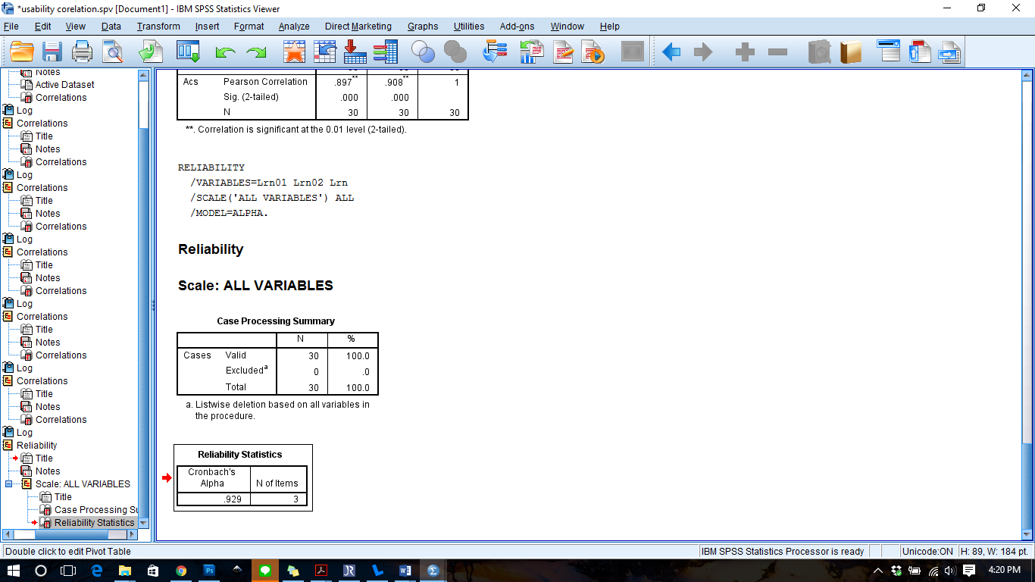

|  |  |
| --- | --- |
| **Reliability Statistics** | |
| Cronbach's Alpha | N of Items |
| .929 | 3 |

QinU

|  |  |  |  |  |
| --- | --- | --- | --- | --- |
| **Correlations** | | | | |
|  | | Eftv01 | Eftv02 | Eftv |
| Eftv01 | Pearson Correlation | 1 | .499** | .907** |
| Sig. (2-tailed) |  | .005 | .000 |
| N | 30 | 30 | 30 |
| Eftv02 | Pearson Correlation | .499** | 1 | .818** |
| Sig. (2-tailed) | .005 |  | .000 |
| N | 30 | 30 | 30 |
| Eftv | Pearson Correlation | .907** | .818** | 1 |
| Sig. (2-tailed) | .000 | .000 |  |
| N | 30 | 30 | 30 |
| **. Correlation is significant at the 0.01 level (2-tailed). | | | | |

|  |  |  |  |  |
| --- | --- | --- | --- | --- |
| **Correlations** | | | | |
|  | | Efcn01 | Efcn02 | Efcn |
| Efcn01 | Pearson Correlation | 1 | .759** | .935** |
| Sig. (2-tailed) |  | .000 | .000 |
| N | 30 | 30 | 30 |
| Efcn02 | Pearson Correlation | .759** | 1 | .940** |
| Sig. (2-tailed) | .000 |  | .000 |
| N | 30 | 30 | 30 |
| Efcn | Pearson Correlation | .935** | .940** | 1 |
| Sig. (2-tailed) | .000 | .000 |  |
| N | 30 | 30 | 30 |
| **. Correlation is significant at the 0.01 level (2-tailed).   |  |  |  |  |  | | --- | --- | --- | --- | --- | | **Correlations** | | | | | |  | | Usef01 | Usef02 | Usef | | Usef01 | Pearson Correlation | 1 | .629** | .900** | | Sig. (2-tailed) |  | .000 | .000 | | N | 30 | 30 | 30 | | Usef02 | Pearson Correlation | .629** | 1 | .906** | | Sig. (2-tailed) | .000 |  | .000 | | N | 30 | 30 | 30 | | Usef | Pearson Correlation | .900** | .906** | 1 | | Sig. (2-tailed) | .000 | .000 |  | | N | 30 | 30 | 30 | | **. Correlation is significant at the 0.01 level (2-tailed). | | | | |  |  |  |  |  |  | | --- | --- | --- | --- | --- | | **Correlations** | | | | | |  | | Trs01 | Trs02 | Trs | | Trs01 | Pearson Correlation | 1 | .632** | .872** | | Sig. (2-tailed) |  | .000 | .000 | | N | 30 | 30 | 30 | | Trs02 | Pearson Correlation | .632** | 1 | .930** | | Sig. (2-tailed) | .000 |  | .000 | | N | 30 | 30 | 30 | | Trs | Pearson Correlation | .872** | .930** | 1 | | Sig. (2-tailed) | .000 | .000 |  | | N | 30 | 30 | 30 | | **. Correlation is significant at the 0.01 level (2-tailed). | | | | |  |  |  |  |  |  | | --- | --- | --- | --- | --- | | **Correlations** | | | | | |  | | Pls01 | Pls02 | Pls | | Pls01 | Pearson Correlation | 1 | .492** | .854** | | Sig. (2-tailed) |  | .006 | .000 | | N | 30 | 30 | 30 | | Pls02 | Pearson Correlation | .492** | 1 | .873** | | Sig. (2-tailed) | .006 |  | .000 | | N | 30 | 30 | 30 | | Pls | Pearson Correlation | .854** | .873** | 1 | | Sig. (2-tailed) | .000 | .000 |  | | N | 30 | 30 | 30 | | **. Correlation is significant at the 0.01 level (2-tailed). | | | | |  |  |  |  |  |  | | --- | --- | --- | --- | --- | | **Correlations** | | | | | |  | | Cmf01 | Cmf02 | Cmf | | Cmf01 | Pearson Correlation | 1 | .165 | .755** | | Sig. (2-tailed) |  | .385 | .000 | | N | 30 | 30 | 30 | | Cmf02 | Pearson Correlation | .165 | 1 | .771** | | Sig. (2-tailed) | .385 |  | .000 | | N | 30 | 30 | 30 | | Cmf | Pearson Correlation | .755** | .771** | 1 | | Sig. (2-tailed) | .000 | .000 |  | | N | 30 | 30 | 30 | | **. Correlation is significant at the 0.01 level (2-tailed). | | | | | | | | | |

|  |  |
| --- | --- |
| **Reliability Statistics** | |
| Cronbach's Alpha | N of Items |
| .871 | 3 |

|  |  |
| --- | --- |
| **Reliability Statistics** | |
| Cronbach's Alpha | N of Items |
| .912 | 3 |

|  |  |
| --- | --- |
| **Reliability Statistics** | |
| Cronbach's Alpha | N of Items |
| .895 | 3 |

|  |  |
| --- | --- |
| **Reliability Statistics** | |
| Cronbach's Alpha | N of Items |
| .892 | 3 |

|  |  |
| --- | --- |
| **Reliability Statistics** | |
| Cronbach's Alpha | N of Items |
| .874 | 3 |

|  |  |
| --- | --- |
| **Reliability Statistics** | |
| Cronbach's Alpha | N of Items |
| .803 | 3 |